Cover Page

I, _*Xiaoxi Zheng*___ affirm that the work submitted is my own and that the Honor  
Code was neither bent nor broken.

The easiest part of this HW is the setup of this project, since the structure of code  
was quite straight forward implemented on top of variety of provided set of codes. The more difficult parts of the HW is buried within implementation of the Game of life algorithm and how the components of JFrame, and JPanel interact with each other. This HW is relatively straight forward comparing to the past couple, and the past HWs are extremely helpful for animation and etc. I spend some time debugging for minor Array Out of Bound at certain places(when testing

I believe the objective of this assignment was for us to reiterate the understanding of the Timer object and implement Animation frame by frame using JPanel and JFrames. How these classes and objects call on each other, and making sure we understand the structural relationship between them. It’s also pretty neat to visually the classic algorithm for Conway’s game of life.

Code

import javax.swing.SwingUtilities;

import javax.swing.JFrame;

import javax.swing.JPanel;

import javax.swing.JButton;

import javax.swing.*;

import javax.swing.JOptionPane;

import javax.swing.JFileChooser;

import javax.swing.JMenuBar;

import javax.swing.JMenu;

import javax.swing.JMenuItem;

import javax.swing.JLabel;

import javax.swing.Timer;

import javax.imageio.ImageIO;

import java.awt.BorderLayout;

import java.awt.Dimension;

import java.awt.Color;

import java.awt.Graphics;

import java.awt.Graphics2D;

import java.awt.Point;

import java.awt.image.BufferedImage;

import java.awt.event.ActionEvent;

import java.awt.event.ActionListener;

import java.awt.event.MouseEvent;

import java.awt.event.MouseAdapter;

import java.awt.event.MouseMotionAdapter;

import java.awt.event.KeyEvent;

import javax.swing.KeyStroke;

import java.io.File;

import java.io.IOException;

import java.util.Random;

public class hw11{

private static final int WIDTH = 800;

private static final int HEIGHT = 800;

public static void main( String[] args){

SwingUtilities.invokeLater( new Runnable() {

public void run()

{

createAndShowGUI();

}

} );

}

public static void createAndShowGUI(){

JFrame frame = new ImageFrame(WIDTH,HEIGHT);

frame.setVisible( true );

}

}

//####################################################################

class ImageFrame extends JFrame {

//static string that represents state of cell with color and int

static private final Color BLACK = Color.BLACK;//indicates dead cell

static private final Color RED = Color.RED;//died this generation

static private final Color GREEN = Color.GREEN;//born this generation

static private final Color BLUE = Color.BLUE;//live cell for more than 1 generation

static private final int DEAD = 0;

static private final int JUST_DIED = 1;

static private final int JUST_ALIVE = 2;

static private final int ALIVE = 3;

static final Color[] colorBaseOnState = {BLACK, RED,GREEN,BLUE};

//a 2D array to hold the states of the each individual cell in the grid

private int [][] cell;

private int MILLESECONDS_BETWEEN_FRAMES;

private DisplayPanel panel;

private JButton button;

private JLabel label;

//changes a cell being alive or dead [0, 1]

private double aliveChance;

private boolean randomWorld;

private int width = 800;

private int height = 800;

private BufferedImage image;

//=========================

public ImageFrame(int width, int height){

this.setTitle("CAP 3027 2015 - HW11 -XiaoxiZheng");

this.setSize( width, height );

this.setDefaultCloseOperation( JFrame.EXIT_ON_CLOSE);

addMenu();////add a menu to the frame

image = simulatedImage(width,height);

panel = new DisplayPanel( image);

cell = new int[100][100];

//initialize every cell to dead

for(int i=0; i<100;i++){

for(int j = 0; j<100;j++){

cell[i][j] = DEAD;

}

}

button = new JButton("Start");

button.addActionListener( new ActionListener(){

public void actionPerformed( ActionEvent event ){

if(!(panel.timerisRunning())) {

button.setText("Pause");

panel.startTimer();

System.out.println("Pause");

}

else{

button.setText("Start");

panel.stopTimer();

System.out.println("Start");

}

}

} );

JSlider slider = new JSlider(JSlider.VERTICAL, 100, 800, 500);

MILLESECONDS_BETWEEN_FRAMES = slider.getValue();

//label = new JLabel("Click Start/Pause to pause and resume your animation");

this.getContentPane().add( panel, BorderLayout.CENTER );

this.getContentPane().add(button, BorderLayout.SOUTH);

this.getContentPane().add(slider,BorderLayout.EAST);

//this.getContentPane().add( label, BorderLayout.NORTH );

this.pack();

this.setVisible( true ); }

private void addMenu(){

JMenu fileMenu = new JMenu("File Menu");

//load IFS description

JMenuItem randPop = new JMenuItem("Randomly Populate World");

randPop.addActionListener( new ActionListener(){

public void actionPerformed( ActionEvent event){

aliveChance = promptForAliveChances();

randomWorld();

}

} );

fileMenu.add(randPop);

JMenuItem emptyWorld = new JMenuItem("Empty World");

emptyWorld.addActionListener( new ActionListener(){

public void actionPerformed(ActionEvent event){

aliveChance = 0;

emptyWorld();

}

} );

fileMenu.add(emptyWorld);

//Save image

JMenuItem saveImage = new JMenuItem("Save Image");

saveImage.addActionListener( new ActionListener(){

public void actionPerformed( ActionEvent event){

saveImage();

}

} );

fileMenu.add(saveImage);

//Exit

JMenuItem exitItem = new JMenuItem("Exit");

exitItem.addActionListener( new ActionListener(){

public void actionPerformed(ActionEvent event){

System.exit( 0 );

}

} );

fileMenu.add( exitItem);

//attach menu to a menu bar

JMenuBar menuBar = new JMenuBar();

menuBar.add( fileMenu);

this.setJMenuBar( menuBar);

}

private void randomWorld(){

randomWorld = true;

configureCellState(aliveChance);

//panel.repaint();

//panel.setImage();

}

private void emptyWorld(){

randomWorld = false;

configureCellState(aliveChance);

//panel.repaint();

//panel.setImage();

}

private void configureCellState(double alive_){

if (alive_ == 0.0) {

//looping thru every grid on the x, y plane

for (int i = 0; i < 100; i++)

for (int j = 0; j < 100; j++)

panel.setState(i, j, DEAD);

} else if (alive_ == 1.0) {

for (int i = 0; i < 100; i++)

for (int j = 0; j < 100; j++)

panel.setState(i, j, ALIVE);

} else {

Random rand = new Random();

for (int i = 0; i < 100; i++) {

for (int j = 0; j < 100; j++) {

if (rand.nextDouble() < alive_)

panel.setState(i, j, ALIVE);

else

panel.setState(i, j, DEAD);

}

}

}

repaint();

}

private void saveImage(){

try

{

File outputfile = new File("life.png");

javax.imageio.ImageIO.write(image, "png", outputfile );

}

catch ( IOException e )

{

JOptionPane.showMessageDialog( ImageFrame.this,

"Error saving file",

"oops!",

JOptionPane.ERROR_MESSAGE );

}

}

private void stop(){

panel.stopTimer();

button.setText("Start");

}

private double promptForAliveChances(){

String input1 = JOptionPane.showInputDialog("Please enter the probability of a random cell being alive [0.0-1.0]");

if(valideInput(input1)){

double temp = Double.parseDouble(input1);

return temp;

}

else if (input1 == null){ //User clicked "Cancel"

System.exit(0);

return -1.99999;

}

else{

return promptForAliveChances();

}

}

private boolean valideInput(String input_){

try{

double num = Double.parseDouble(input_);

if(num<0 || num > 1){

JOptionPane.showMessageDialog(null, "Invalid Input", "alert", JOptionPane.ERROR_MESSAGE);

return false;

}

return true;

}

catch(NumberFormatException e){

JOptionPane.showMessageDialog(null, "Invalid Input", "alert", JOptionPane.ERROR_MESSAGE);

return false;

}

}

protected BufferedImage simulatedImage(int width_,int height_){

while (true) {

if (width_ < 0 || height_ < 0)

return null;

try {

BufferedImage img = new BufferedImage(width_,height_,BufferedImage.TYPE_INT_RGB);

return img;

} catch (OutOfMemoryError err) {

JOptionPane.showMessageDialog(this, "Ran out of memory! Try using a smaller image size.");

}

}

}

//nested FractalDisplayPanel class

private class DisplayPanel extends JPanel{

// panel size

private final int WIDTH, MAX_X;

private final int HEIGHT, MAX_Y;

// image displayed on panel

private BufferedImage image;

private Graphics2D g2d;

private Point currentMouse;

private Timer timer;

//use by mouse events

private int mAliveState;

private boolean isARGBColor( Point p, int argb ){

return (image.getRGB( p.x, p.y ) == argb );

}

//------------------------------------------------------------------------

// constructor

public DisplayPanel( BufferedImage image ){

this.image = image;

g2d = image.createGraphics();

// define panel characteristics

WIDTH = image.getWidth();

HEIGHT = image.getHeight();

MILLESECONDS_BETWEEN_FRAMES = 500;

Dimension size = new Dimension( WIDTH, HEIGHT );

setMinimumSize( size );

setMaximumSize( size );

setPreferredSize( size );

MAX_X = WIDTH - 1;

MAX_Y = HEIGHT - 1;

currentMouse = null;

//initialize Timer

timer = new Timer(MILLESECONDS_BETWEEN_FRAMES, new ImageLooper());

this.addMouseListener( new MouseAdapter(){

public void mousePressed( MouseEvent event ){

if(!timer.isRunning()){

currentMouse = event.getPoint();

int i = ((currentMouse.x >>3) << 3) / 8;

int j = ((currentMouse.y >>3) << 3) / 8;

if (isAlive(cell[i][j])){

mAliveState = DEAD;

}

else{

mAliveState = ALIVE;

}

setState(i, j, mAliveState);

}

}

});

this.addMouseMotionListener( new MouseMotionAdapter(){

public void mouseDragged(MouseEvent event){

if(!timer.isRunning()){

currentMouse = event.getPoint();

int i = ((currentMouse.x >>3) << 3) / 8;

int j = ((currentMouse.y >>3) << 3) / 8;

setState(i, j, mAliveState);

}

}

});

}

//------------------------------------------------------------------------

private void setState(int x_, int y_, int state_){

//wraps around and preten to be a tortorial plane

if (x_ < 0)

x_ = 100- 1;

else if (x_ >= 100)

x_ = 0;

if (y_ < 0)

y_ = 100 - 1;

else if (y_ >= 100)

y_ = 0;

//where (x,y) is the coordinate and state is represented by an int.

cell[x_][y_] = state_;

//draw the state reflecting changes

//if(isAlive(state_)){

//drawSquare(x_,y_,true,state_);

//}

//else{

drawSquare(x_,y_,state_);

//}

}

private boolean isAlive(int state_){

if(state_ == ALIVE || state_ == JUST_ALIVE){

return true;

}

else{

return false;

}

}

private void drawSquare(int x_,int y_,int state_){

//if(alive_){

g2d.setColor( colorBaseOnState[state_] );

g2d.fillRect( x_*8, y_*8, 8, 8 );

repaint();

//setImage;

}

/*

public void setImage( BufferedImage src ){

g2d.drawImage( src,

0, 0, MAX_X, MAX_Y,

0, 0, (src.getWidth() - 1), (src.getHeight() - 1),

null

);

repaint();

}

*/

//------------------------------------------------------------------------

// behaviors

public void paintComponent( Graphics g ){

super.paintComponent( g );

g.drawImage( image, 0, 0, null );

}

public boolean timerisRunning(){

return timer.isRunning();

}

public void stopTimer(){

timer.stop();

}

public void startTimer(){

timer.start();

}

private class ImageLooper implements ActionListener{

private int [] xMoore = {-1,0,1};

private int [] yMoore = {-1,0,1};

public void actionPerformed(ActionEvent evt){

//

int [][] newCell;

newCell = new int[100][100];

//initialize every new cell to dead

for(int i=0; i<100;i++){

for(int j = 0; j<100;j++){

newCell[i][j] = DEAD;

}

}

for (int j = 0; j < 100; j++) {

for (int i = 0; i< 100; i++) {

int aliveNeighbors = 0;

//for (int x=-1; x<2;x++ ){ // cycle through the Moore neighborhood of the current cell, checking whether each cell is alive

//for (int y=-1; y<2; y++) {

for(int x : xMoore){

for(int y : yMoore){

int tempX = i+x;

int tempY = j+y;

//clamp values to wrap around

if(tempX<0){

tempX = 100-1;

}

else if(tempX>=100){

tempX = 0;

}

if(tempY<0){

tempY=100-1;

}

else if(tempY >=100){

tempY =0;

}

if (x == 0 && y == 0)

// exclude the cell itself from the count

continue;

if (isAlive(cell[tempX][tempY])) {

++aliveNeighbors;

}

}

}

if (isAlive(cell[i][j])) { // if the cell is alive

if (aliveNeighbors < 2 || aliveNeighbors > 3) {

// kill it bc too lonely or too crowded

newCell[i][j]=JUST_DIED;

drawSquare(i,j,JUST_DIED);

}

else { // keep it alive

if (cell[i][j] == JUST_ALIVE){

newCell[i][j]=ALIVE;

drawSquare(i,j,ALIVE);

}

else{

// otherwise, make sure to transfer the cell state over to the new world

//setState(i, j, cell[i][j]);

newCell[i][j] = cell[i][j];

drawSquare(i,j,newCell[i][j]);

}

}

}

else { // if the cell is dead, either...

if (aliveNeighbors == 3){

// bring it to life, or

//setState(i, j, JUST_ALIVE);

newCell[i][j] = JUST_ALIVE;

drawSquare(i,j,JUST_ALIVE);

}

else { // keep it dead

if (cell[i][j] == JUST_DIED) {

// change state to a "permanent" dead state if it just died last frame

//setState(i, j, DEAD);

newCell[i][j] = DEAD;

drawSquare(i,j,DEAD);

}

else {

// otherwise, make sure to transfer the cell state over to the new world

//setState(i, j, cell[i][j]);

newCell[i][j]= cell[i][j];

drawSquare(i,j,newCell[i][j]);

}

}

}

}

}

cell = newCell;

repaint();

}//action performed

}//image looper

}//DisplayPanel

}//Jframe

Questions

1. Does the program compile without errors?  
Yes.  
2. 2. Does the program compile without warnings?  
Yes  
3. 3. Does the program run without crashing?  
Yes  
4. 4. Describe how you tested the program.  
I ran several test cases with different random inputs for the chances of a cell being alive. And give simple test case on empty world  
set is displaying and zooming correctly.  
5. Describe the ways in which the program does not meet assignment's specifications.  
In the GIFs I provided, the image appear to be tearing a bit, and slow to update for every frame. I based  
on the assumption that could be the nature of my Graphics Card and the amount of other programs I  
had running on my laptop at the time.  
6. Describe all known and suspected bugs.  
There are no known bugs.  
7. Does the program run correctly?  
Yes

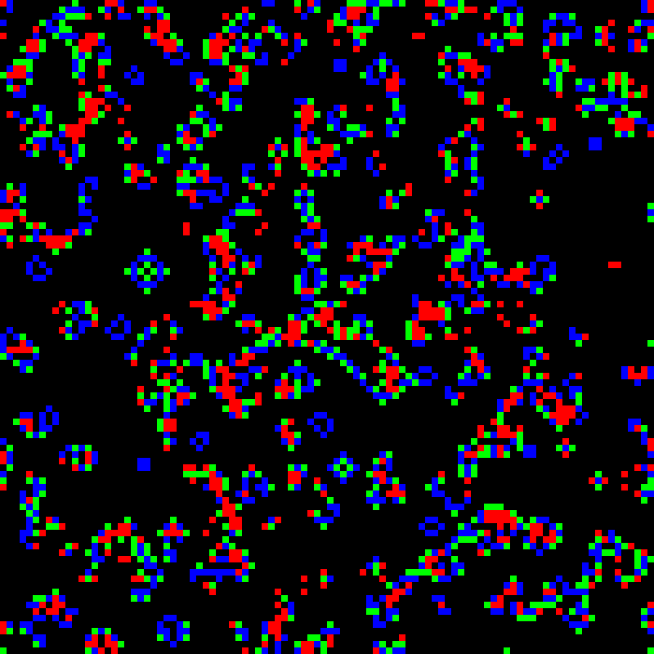Screenshots

